Hutt and Rembuden Kendo Clubs welcome your interest in attending the 2nd Wellington Summer Gasshuku! The following briefing pack has been prepared to provide information on the Gasshuku including advice on looking after yourself during the high intensity training. If you have any questions not answered here, give me a call (027 2144 206) or email me (richardtremain@hotmail.com).

Kind regards

Richard Tremain

Gasshuku location and times

The Gasshuku will be held in the main gymnasium, Victoria University, Karori Campus, Wellington.

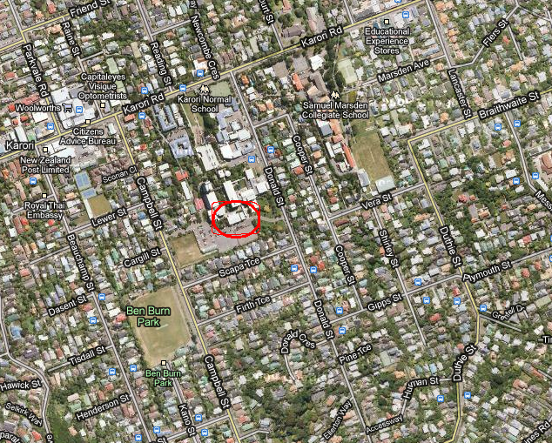

Training will take place between the following times:

Date | Time
Saturday 12th February | 7 am – 5 pm
Sunday 13th February | 7 am – 4 pm

Training format

The Gasshuku will consist of high intensity Kendo training. Specifically the training format will involve 4 sessions per day with lots of suburi, kirikaeshi, uchikomi, kakarigeiko and ji-geiko. There will also be breaks between sessions to enable recovery and hydration.

Arriving early

To facilitate the smooth running of the Gasshuku please be ready in bogu 15 mins prior to the start time. The dojo will be open from 6.30 a.m. to facilitate this.

Food and drinks

Drinks and food will not be provided, however there are shops a short walk from the dojo that participants will be able to buy these from. It is recommended that you have at least two litres of fluid (preferably isotonic) to drink per day.

Cost

Participants are asked to contribute $20 to help cover the cost of venue hire for the Gasshuku. Please give this money to Richard Tremain.

Looking after yourself

- Preparation: The Summer Gasshuku is a physically demanding weekend of high intensity training. To participate fully for the entire two days, attendees must have a high level of ‘Kendo fitness’. Attendees need to be developing this at least several months before attending.

- Pre-existing medical conditions: Any pre-existing medical conditions e.g. strains, asthma, pulled muscles etc. need to be brought to the attention of Richard Tremain before the Gasshuku begins. If you have more serious pre-existing medical conditions e.g. heart condition, it is recommended you consult your doctor prior to attending.

- Hydration: You will need to drink a lot during the Gasshuku to replace the fluids you lose. We have set aside times to hydrate. Please take these opportunities to replace lost fluids. Isotonic sports drinks e.g. Horleys Replace, Powerade, are a good option here. Water by itself will be insufficient as you will lose sodium through sweating which may result in muscle cramps. If you are making up your own drink, put in a pinch of salt to reduce the likelihood of this happening.

- Feet: Bring tape to cover any cracks/blisters that develop. An emulsifying cream or heel balm will soften your feet and reduce the likelihood of painful cracks.

- Feeling ill: You will be expected to participate fully in the Gasshuku and to push yourself throughout. If you are struggling to continue, tell your motodachi, bow out correctly, and sit at the side of the dojo until you are ready to continue again. Do not leave the dojo without informing one of the senior trainers (Sue/Liz/Martin/Richard).

Registration
To register for the Gasshuku, please email Richard Tremain (richardtremain@hotmail.com) with the following details:

- Your name (first and surnames)
- Your club
- Your grade
- Information on any pre-existing medical conditions that may impact on your ability to participate in the training
- Whether you are able to act as motodachi for kihon, uchikomi, and kakarigeiko

Please note: You must be wearing bogu to participate in the Gasshuku.

